ABSTRACT

The aim of this project is to develops an online search Portal for the Placement Dept. of the college. The system is an online application that can be accessed throughout the organization and outside as well with proper login provided. This system can be used as an Online Job Portal for the Placement Dept of the college to manage the student information with regards to placement. Students logging should be able to upload their information in the form of a CV. Visitors/Company representatives logging in may also access/search any information put up by Students.The project has been planned to be having the view of distributed architecture, with centralized storage of the database. The application for the storage of the data has been planned. Using the constructs of MS-SQL Server and all the user interfaces have been designed using the ASP.Net technologies. The database connectivity is planned using the “SQL Connection” methodology. The standards of security and data protective mechanism have been given a big choice for proper usage. The application takes care of different modules and their associated reports, which are produced as per the applicable strategies and standards that are put forwarded by the administrative staff.

OBJECTIVE

The main objective of job portal system is to manage the details of interview, post job, call letter, search job, employer registration. It manages all the information about interview, employer, employer registration, interview. The project is totally built at administrative end and thus only the administrator is guaranteed the access. The purpose of the project is to build an application program to reduce the manual work for managing the interview, post job, employer, call letter. It tracks all the details about the call letter, search job, employer registration.

Some of the objectives that our development team had to achieve were:

* Design and develop highly effective management system for the website
* Design a user-friendly interface
* Segregated search option for the users on the basis of industry, country, keyword etc.
* An advanced administration panel for easy management of the job seekers as well as employers profile
* Interactive website with informative tools like newsletters, career resources
* Member engagement through forums

FEATURES

The user can also save a job which will be available in the save list. The visitors can apply to job by simply clicking on the apply button. The user can search for different jobs by typing the job title in the search bar. Here, the jobs page is only available to the admin user.

The admin can add, edit and delete jobs but a default user can only apply, save and clear jobs. Moreover, a visitor can make a new account on the online job portal by registering using an email. Also, users can change the password if he/she forgets it.

The css/style.css file helps to give the site a minimal and beautiful look and the project use bootstrap for consistent design across several pages. But, this online job portal project mostly focuses only on PHP and MySQL so there are minimal CSS and JavaScript code. JavaScript helps in the search function to make it quick and seamless. Similarly, there is use of localStorage web api to save the job to the job list. Also, template folder contains files which decrease code repetition like header codes which is same in many pages. There are two tables in the database i.e. users and job

INTRODUCTION

Technology is constantly changing, society as we know depends on this fact. That which we take for granted today would have been the stuff of science fiction as little as fifty years ago. In the early years of the twenty first century, it is computers and the internet that have captured the public imagination, and found their way into not just the working environments, but increasingly into the domestic spaces. In this modern society, if we are not capable to cope up with these changes than we are not going to stand or survive anywhere in this technical world.

Today there is no place for errors, so as to make a system more effective and efficient we need such technology where error prone chances must be least. In the scenario of this project, we are required to develop a web -based application on job portal management system. In this time of recession where everyone, is either experienced or fresher, is in search for a job. This job portal can prove to be very helpful since it allows users of different profile to upoad their CVs, search job on the basis of their qualification.

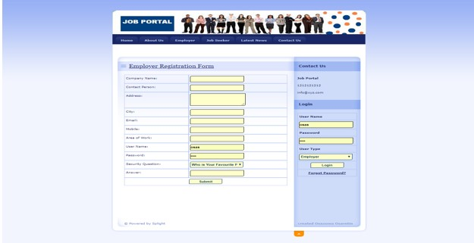

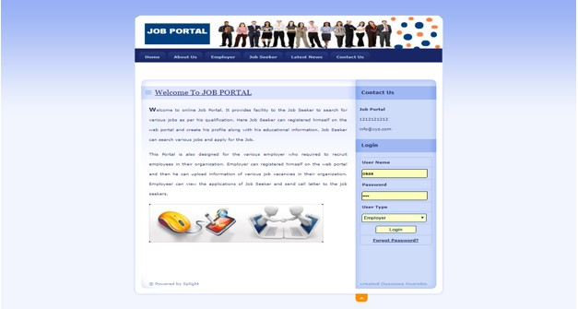

METHODOLOGY

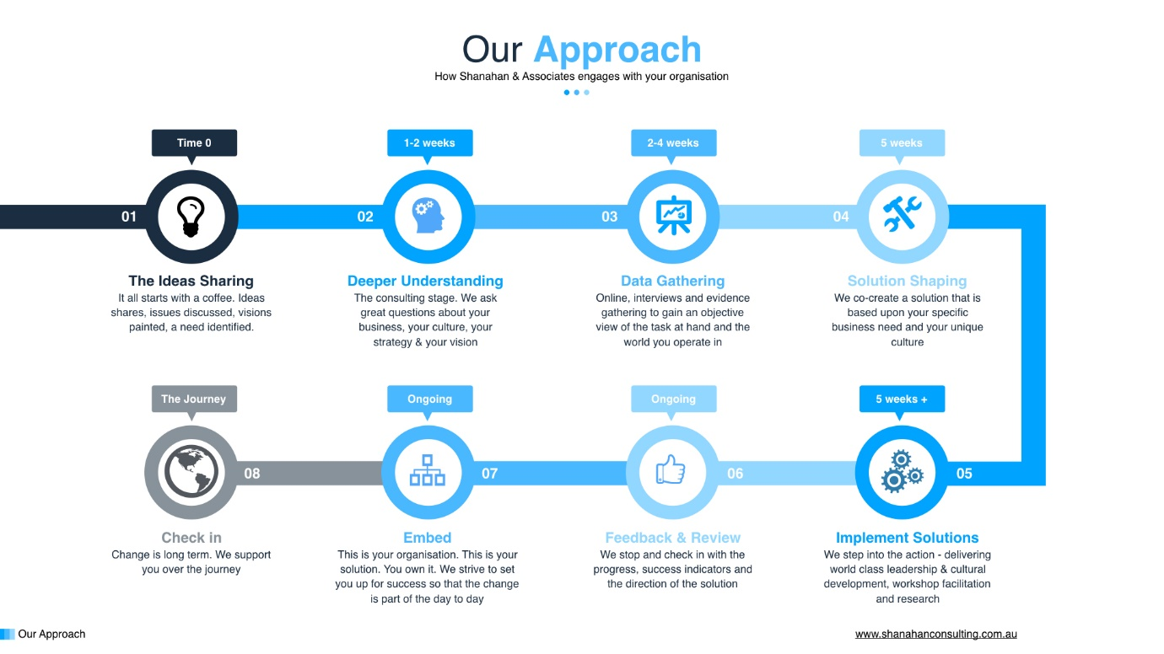

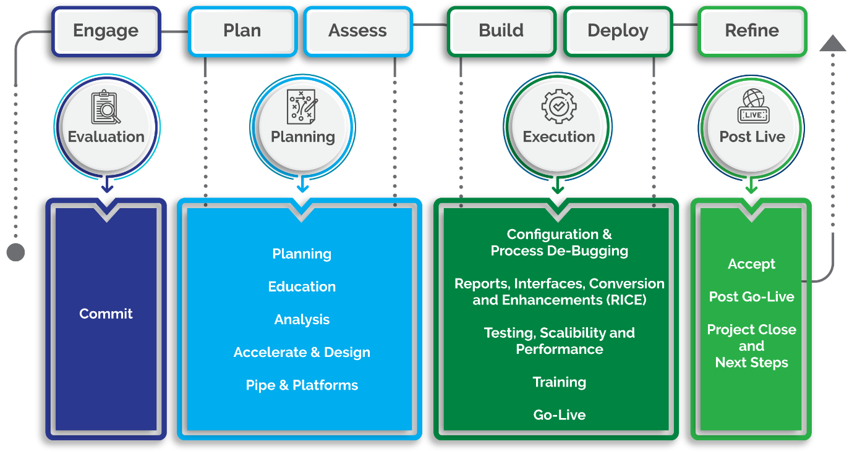



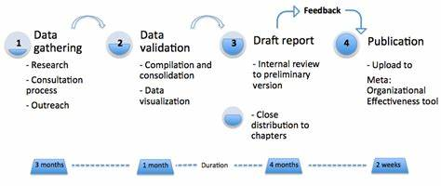

CODE

.search{

width: 100%;

max-width: 1200px;

height: 42px;

margin: 0 auto;

}

.search-container{

display: flex;

justify-content: space-between;

height: 100%;

border: none;

margin-top: 1%;

}

.search-container .input-container{

width: 40%;

display: flex;

flex-grow: 1;

background: transparent;

border: none;

border-bottom: ridge;

margin-right: 1%;

}

.search-container .input-container i{

display: flex;

justify-content: center;

align-items: center;

font-size: 147%;

}

.search-container .input-container input{

width: 96%;

height: 100%;

background: transparent;

border: none;

margin-left: 2%;

margin-right: 2%;

color: white;

font-size: 140%;

outline: none;

}

.search-container .btn-container{

border-radius: 5px;

display: flex;

justify-content: center;

align-items: center;

background: darkblue;

width: 14%;

height: 100%;

}

.search-container .btn-container:hover{

background: blue;

cursor: pointer;

}

.job-container{

height: 100vw;

margin: 2% auto;

width: 1220px;

}

.job-container-heading{

display: flex;

width: 100%;

height: 7%;

font-size: 20px;

align-items: center;

justify-content: flex-start;

padding-left: 2%;

}

.job-tile-container{

width: 100%;

display: grid;

height: 93%;

grid-template-columns: repeat(3,1fr);

grid-template-rows: repeat(3,1fr);

gap: 24px;

}

.job-tile-container .job-tile{

background: rgb(1, 1, 17);

border-radius: 20px;

border: 1px solid;

display: flex;

flex-direction: column;

}

.job-tile-container .job-tile:hover{

transition: all .5s ease;

transform: scale(1.05);

}

.job-tile .job-tile-head{

display: flex;

flex-grow: 1;

justify-content: space-between;

width: 100%;

height: 10%;

border-radius: 20px;

background: rgb(0, 0, 0);

}

.job-tile .job-tile-head .logo{

margin-left: 2%;

width: 7%;

height: 100%;

}

.job-tile .job-tile-head .logo img{

height: 100%;

width: 100%;

border-radius: 6px;

}

.job-tile .job-tile-head .dots{

margin-right: 5%;

display: flex;

align-items: center;

font-size: 190%;

}

.job-tile .job-tile-head .dots:hover{

cursor: pointer;

}

.job-tile .job-tile-title{

width: 100%;

flex-grow: 1;

display: flex;

align-items: center;

padding-left: 2%;

font-size: 24px;

cursor: pointer;

border-bottom: 5px solid rgb(47, 47, 223);

}

.job-tile .job-tile-desc{

width: 98%;

height: 62%;

display: flex;

flex-grow: 1;

flex-direction: column;

justify-content: center;

align-items: center;

margin: 0 10px;

font-size: 16px;

}

.job-tile .btns{

display: flex;

justify-content: space-between;

height: 13%;

margin-bottom: 1%;

}

.job-tile .btns .apply{

border-radius: 10px;

width: 30%;

display: flex;

height: 100%;

margin-left: 5%;

font-size: 150%;

justify-content: center;

align-items: center;

background: rgb(52, 9, 70);

flex: 1;

margin-right: 1%;

}

.job-tile .btns .message{

border-radius: 10px;

width: 30%;

display: flex;

height: 59%;

justify-content: center;

align-items: center;

font-size: 150%;

margin-right: 5%;

height: 100%;

background: darkblue;

flex: 1;

margin-left: 1%;

}

.job-tile .btns .message:hover{

background: rgb(18, 18, 236);

cursor: pointer;

}

.job-tile .btns .apply:hover{

background: rgb(87, 43, 87);

cursor: pointer;

}

OUTPUT:

JOB PORTAL HOME PAGE

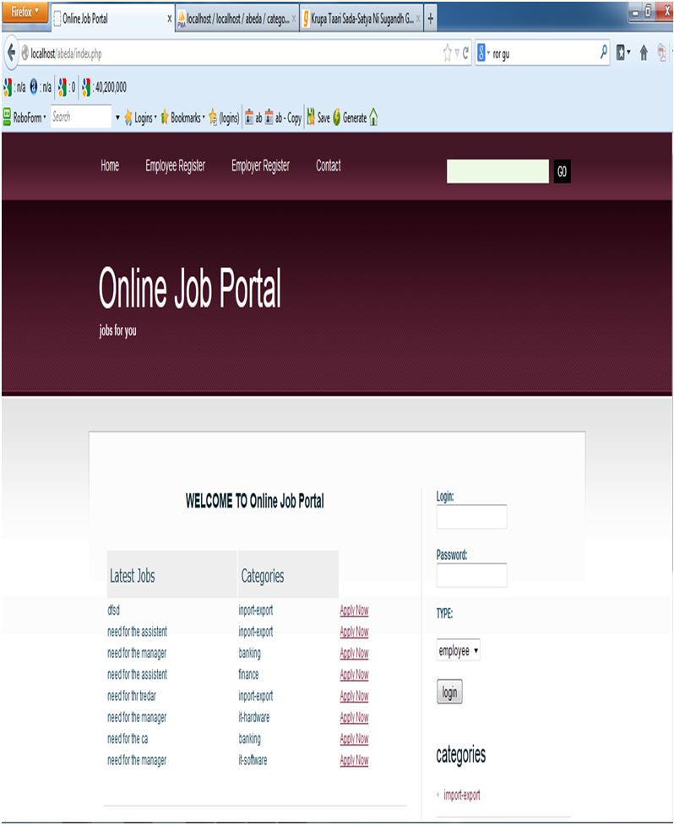

ADMIN PAGE

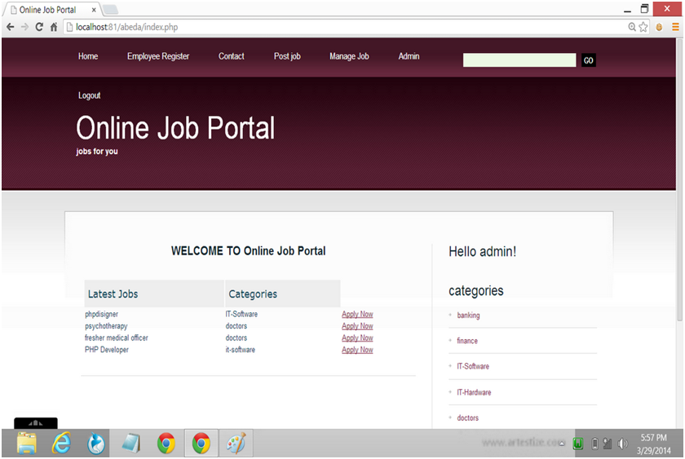

MANAGE JOB PAGE

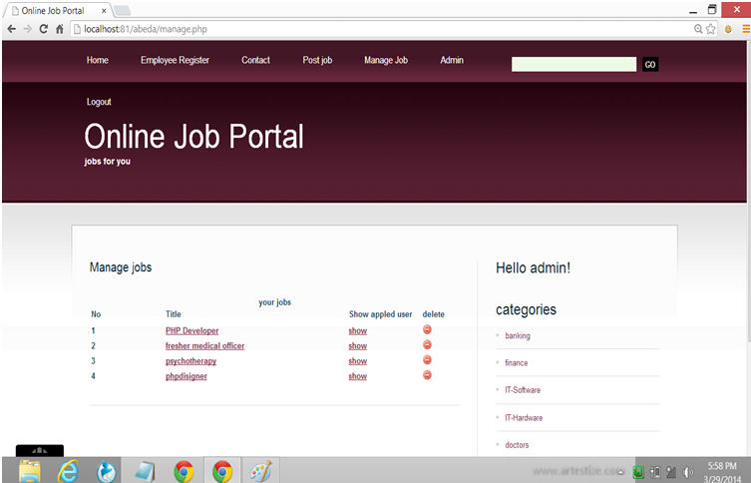

EMPLOYEE REGISTRATION PAGE

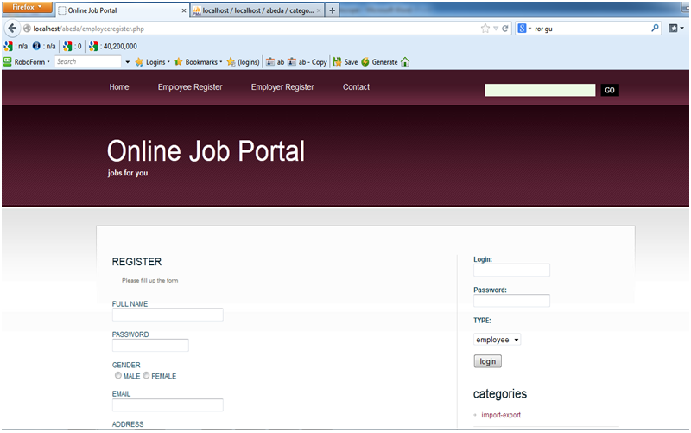

JOB POST PAGE

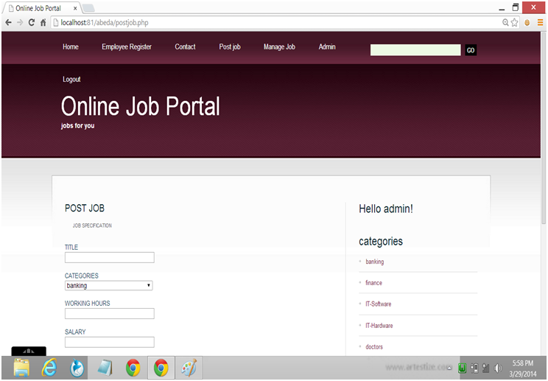

ADVANTAGES

* Using e-commerce, organizations can expand their market to national and international markets with minimum capital investment. An organization can easily locate more customers, best suppliers, and suitable business partners across the globe.
* E-commerce helps organizations to reduce the cost to create process, distribute, retrieve and manage the paper based information by digitizing the information.
* E-commerce improves the brand image of the company.
* E-commerce helps organization to provide better customer services.
* E-commerce helps to simplify the business processes and makes them faster and efficient.
* E-commerce reduces the paper work.
* E-commerce increases the productivity of organizations. It supports "pull" type supply management. In "pull" type supply management, a business process starts when a request comes from a customer and it uses just-in-time manufacturing way.

DISADVANTAGES

* There can be lack of system security, reliability or standards owing to poor implementation of e-commerce.
* The software development industry is still evolving and keeps changing rapidly.
* In many countries, network bandwidth might cause an issue.
* Special types of web servers or other software might be required by the vendor, setting the e-commerce environment apart from network servers.
* Sometimes, it becomes difficult to integrate an e-commerce software or website with existing applications or databases.
* There could be software/hardware compatibility issues, as some e-commerce software may be incompatible with some operating system or any other component.

CONCLUSION

* The quality of the system depends on number of factors such as design ,development , testing and implementation.one vital aspects of system quality is reliability . A system is also said to reliable when used it doesn’t produce failure that is dangerous and costly.
* I have strived to prevent occurrence of errors using different methods and techniques that include error detection , correction and tolerance.